Sandgate Parish Council – Half Year Finance Report to 30th September 2024

Firstly, an apology that this report is later than normal. This is down to me, as I have struggled to find the time to undertake a deep dive into the numbers. I have found doing a deep dive continues to be an extremely useful exercise.
I have also been considering how we change the format of the reporting from my usual free flow style into something that more structured which would be easier for Chani to start producing. I will still be doing my deep dive though.
Having been spending lots of time recently trying new things with Scribe I am going to share a budget report that I do not think you will have seen previously. Scribe continues to impress and remains a must have tool for us offering superb value for money. I have attached a copy of the report which is called Net Position by Cost Centre and Code (between dates – on this occasion this for the six months until 30th September).
You will see from the report that expenditure codes are grouped within individual subheadings. This is a similar format to the draft budget which we will be looking at very closely next month. I will comment within each subheading – please read in conjunction with the Scribe report.
AEP – Leased Land
No activity – no comment.
CCTV
During my deep dive I noted two invoices, months apart, of slightly different amounts that related to the replacement CCTV works we had undertaken during the period. Having questioned both invoices one was refunded and will appear in the next update. This will reduce the spend on Code 54 by around £700. Unless we have any unpleasant surprises during the remainder of the budget year we will be on budget with CCTV.
LAM – Granville Parade
Whilst we have had no Solar Panel Mobile data costs (we will have the same budget next year) other costs are lower than I would have anticipated probably because of the poor summer weather. I anticipate we will be slightly below budget spend this year. If so, we can consider having another deep clean done in late March before Easter.
LAM Maintenance (Leased Lands)
We are presently awaiting quotes for the works required following receipt of the annual tree report. The report itself was more expensive than budgeted so the budget will need to be increased for next year. My suspicion is that the tree works will seriously deplete our residual budget for general maintenance in the parks. This may impact on our ability to undertake smaller jobs for the remainder of the budget year unless we are able to find funds to vire from elsewhere. I am working on this.
Library Running Costs
Code 9 – Handyman – the following is a summary of the YTD costs. The PAT testing is required every five years and was not included in the budget. The Flu replacement was also not anticipated. I anticipate that 50% of the costs will be reimbursed by KCC.
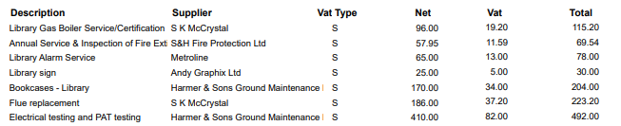
Code 12 – Minor Refurbishment Costs the following is a summary of the YTD costs.
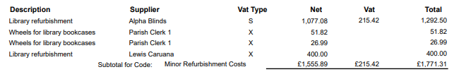
The Blinds costs were met from the COVID reserve which has finally been fully used. Used.
The Library Mural (Lewis Caruana) were met from a grant.

Loan Interest - PWLB
The loan repayment during the period has been met as due.

Parish Council Costs
We have big areas of seasonality within this cost area. These are principally around Hanging Baskets and Christmas lights. These will impact in the early New Year.
Code 119 – PWLB Solar Loan repayments – this code has been used to meet planning application costs.
Code 31 – Sea Festival. We still need to make our donation to the RNLI.

Precept
Funds received as forecast.

Total other Receipts
Code 61 – PWLB Investment Interest. I have asked Chani to produce a summary of the interest we anticipate receiving by the year end. A number of the accounts pay interest annually just prior to our year end.
Code 64 + Code 79 KCC Recharges. I know that Chani is doing some work around reviewing our historic claims. Income on both lines is lower than I would expect and appear to be a chargeback quarter light on receipts.
An update on year-to-date income will be included on Decembers Finance Agenda.

Simon Horton
17th November 2024

